Multivariate Analysis

Data Cleaning and Alignment
Inclusion of multiple explanatory variables presents several technical problems.

- Data gathered from different sources does not have the same degree of credibility.
- Often, different variables/factors are gathered on different intervals (e.g. monthly, quarterly, yearly).
- Data does not span across identical time ranges across variables, specifically, some data may be limited relative to others temporally.
- Variables may have a co-integrating factor, and inclusion of two such variables in such a regression would be redundant.

To address 2 and 3, we applied sufficient cut-offs to ensure proper temporal alignment, and linearly interpolated the data from annual/quarterly to monthly.

Exploratory Data Analysis

To assess the need for data transformations, the ACF of the original multivariate data was inspected. Each original series shows a clear unit-root, thus, a simple return transformation was taken for each variable. The resultant ACF plot is shown in figure 5.B.1, for a handful of candidate explanatory variables. This step was necessary, since the use of non-stationary data in a multiple regression analysis can result in spurious regression coefficients and incorrect p-values.

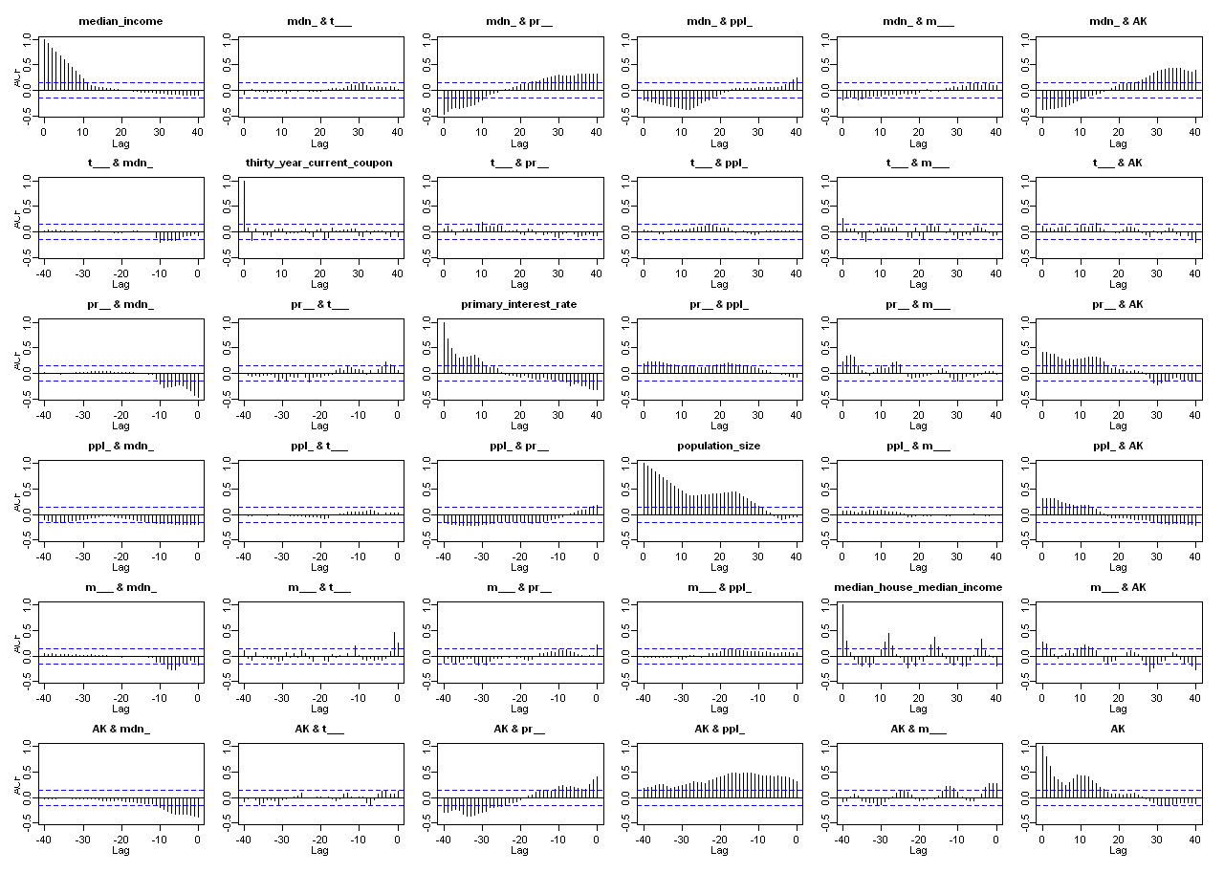
Figure 5.B.1: ACF/CCF of explanatory variables and AK HPI simple returns.

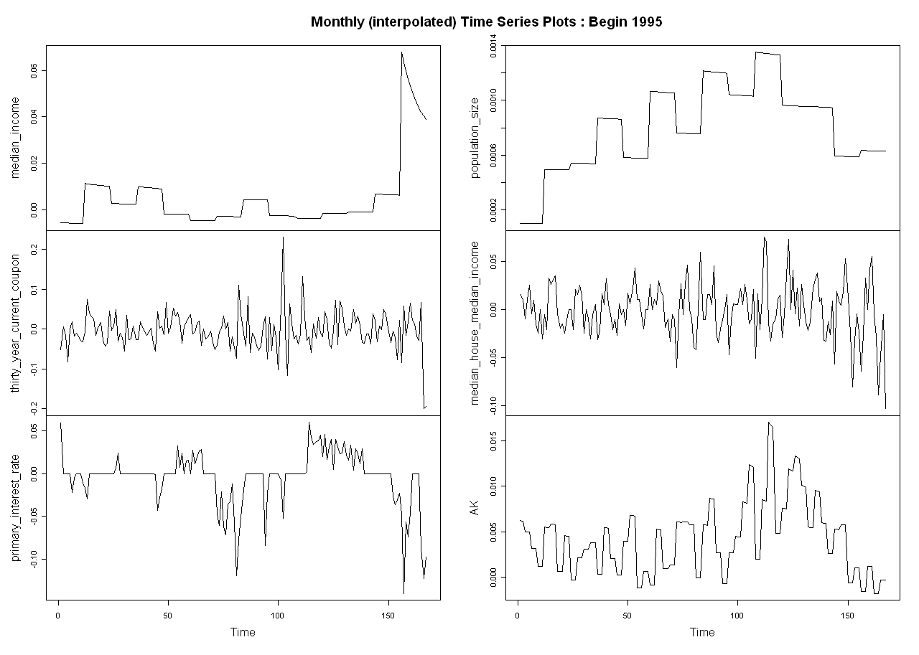
Figure 5.B.2: Time series plot of explanatory variables and AK HPI simple returns.

Multiple Linear Regression and Results
After taking appropriate tranformations, different sets of explanatory variables were used to attain the highest R² for the multivariate regression. We attained the best regression results with the following set of predictors:

AK ~ median_income +
thirty_year_current_coupon +
primary_interest_rate +
population_size +
median_house_median_income

Estimates
Simple Return | Coeff. | Std.  Error | t-  value | Pr(>|t|)
(Intercept) | 2.30E-03 | 7.60E-04 | 3.09E+00 | 2.30E-03
Median Income | -5.52E-02 | 2.10E-02 | -2.57E+00 | 1.11E-02
Thirty Year Current Coupon | 3.70E-03 | 5.80E-03 | 6.50E-01 | 5.19E-01
Primary Interest Rate | 3.08E-02 | 9.90E-03 | 3.11E+00 | 2.20E-03
Population Size | 2.80E+00 | 8.70E-01 | 3.23E+00 | 1.50E-03
Median House Median Income | 2.29E-02 | 1.00E-02 | 2.26E+00 | 2.49E-02
Table 5.C.1: Regression coefficients and statistics

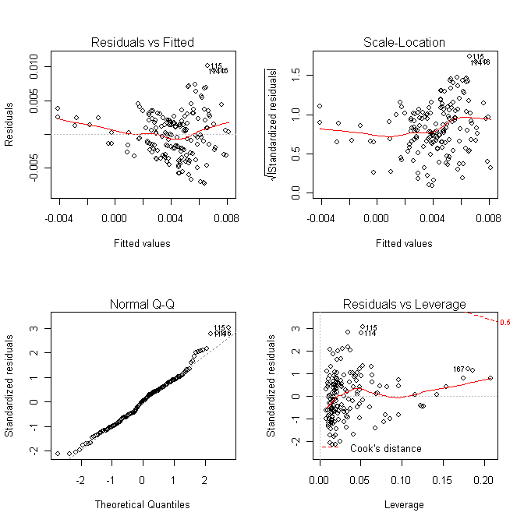
Figure 5.C.1: Residual Analysis

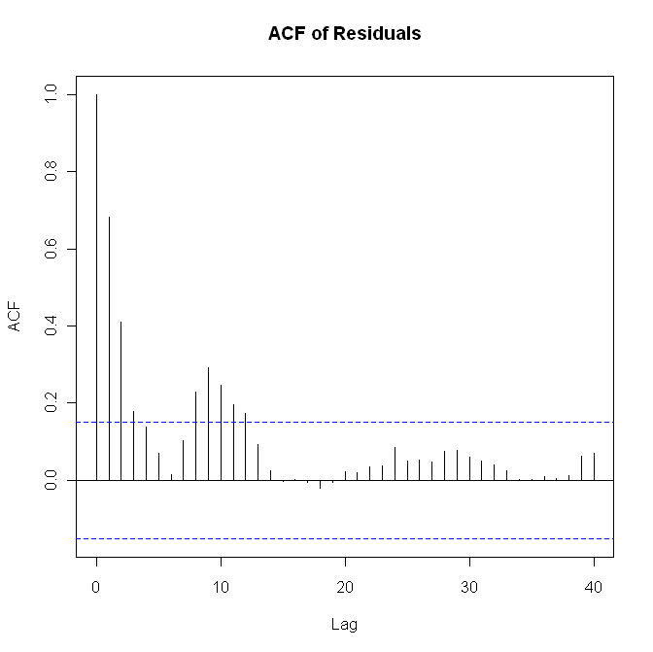 | 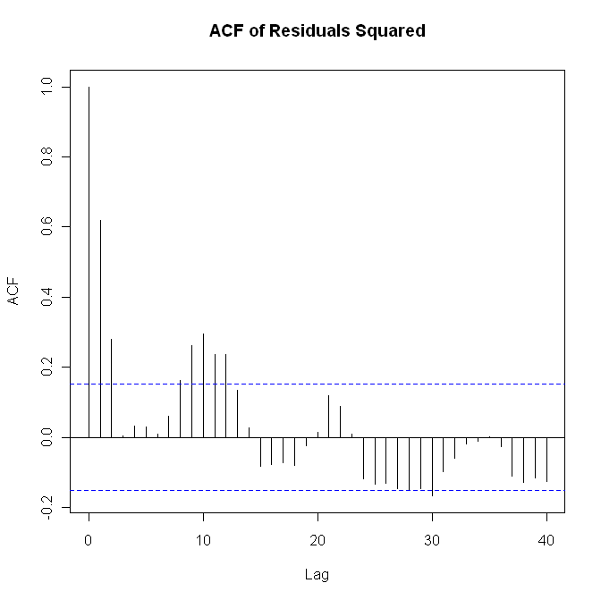
Figure 5.C.2: Residual ACF Plots
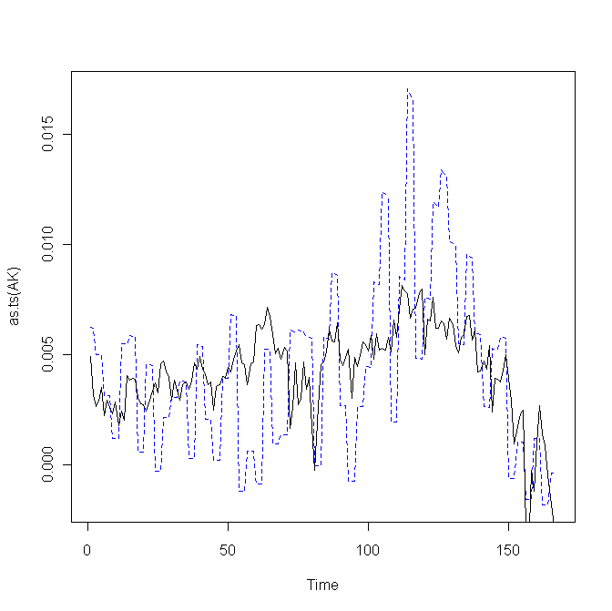
AK vs Fitted : Begin 1995

Figure 5.C.3: Time Series Plots (original vs fitted).

